Milestone 1

September 29, 2020

# Opportunity Statements

1. Developing an application that will allow users to monitor the moisture, temperature and light exposure of house plants for the general market.
2. Developing an application that will allow users to observe the color of their urine and in turn have the app give the user information on dehydration levels, as well as suggested water intake. For the general market.
3. Developing an application that will monitor rooms in a house with cameras and motion sensors, which will then send information of potential intruders directly to the application. For the home security market.
4. Developing an application that will listen to users and provide real-time captions (speech-to-text) to be used in the disabilities market.
5. Developing an application in tandem with a smart table which will enable the latter to adjust the height at varying times to ensure the users good posture. For the office market.
6. Developing a pulse monitor application that will measure the heart-rate of the user and send other related information to the application. For the medical and joggers market.

# Evaluation of Opportunity Statements

1. General evaluation: Project that allows us to monitor plant soil and environment over time, giving users the idea or reminders about further plant care. Will allow users to save money in the long run since they won't have to buy new plants.
   1. Feasibility: realistic, off-the-shelf components are available, members have experience with similar projects.
   2. Target audience: general population, owners of home plants who are forgetful and who do not have much experience in botany and/or plant care.
   3. Competition: Somewhat competitive since similar products exist, ex.: Parrot Pot. We will be concentrating on data over time collection with a rugged system for various environments.
2. General evaluation: Device that measures the color of urine in the toilet bowl. It can indicate the general health of the user, by tracking the color of their urine over time and giving feedback on water drinking habits that would, in theory, improve their health over time.
   1. Feasibility: Doable through photospectrometry or camera image recognition, concerns over research time and use environment (sanitary + acidity).
   2. Target audience: Entire human species. Everybody pees, and people cannot translate the color of urine to the amount of water that they have to consume.
   3. Competition: No significant competition.
3. General evaluation: Gives peace-of-mind when away and at home for personal belongings. Can prevent robberies and break ins, by notifying the owner of suspicious activity. Important footage can be relayed to the police department for their investigations. Sensors and processing units aren’t cumbersome, as they are hidden in corners of the room.
   1. Feasibility: Very doable, off-the-shelf sensor and technologies already exist. The coordination of these sensors could add complications to the project.
   2. Target audience: Anyone who has valuable items in their household and/or people that have security concerns.
   3. Competition: Very strong competition, technology and finance wise.
4. General evaluation: app that will translate speech to text for people, with the possibility of translation. Can also be useful to people that aren’t familiar with the spoken language, and would better understand it with subtitles.
   1. Feasibility: Doable, given Google APIs and available libraries. The hardest idea software-wise, we have more hardware expertise than software. In addition we are not sure whether we will be able to train the AI.
   2. Target audience: Deaf people.
   3. Competition: Alphabet Inc. (Google).
5. General evaluation: The project would help in learning to have better posture, by forcing people to change positions (sitting/standing) during the day. This could eliminate blood circulation system problems and improve posture leading to better spine health and cardiovascular health in the long run. These tables could be used by multiple users with their personalized profile on their android application. The table would require an electrical outlet and will have higher costs than a normal desk.
   1. Feasibility: very doable, members have experience with similar projects with mechanical tables using actuators.
   2. Target audience: office workers and students.
   3. Competition: Manual adjustable height tables such as IKEA tables.
6. General evaluation: Device that allows you to track heartbeat over time, giving a competitive edge over other competitors since a lot of devices don’t track heartbeat over time.
   1. Feasibility: existent technology, sensors are widely available. May not be comfortable to wear if designed by ELEC/COEN 390 students due to limited manufacturing capabilities.
   2. Target audience: People who do sports.
   3. Competition: Very competitive market with existing products. Most fitness watches have that function built-it.

# Ranking of Opportunity Statements

Ranking of Opportunity Statements was performed after the Evaluation of Opportunity Statements via weighted voting on excel spreadsheet.

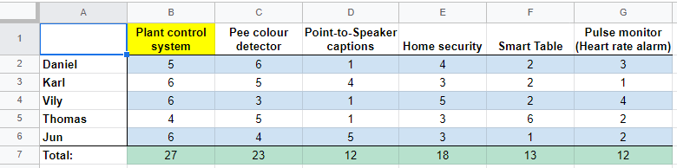

The ranking is as follows:

1. Plant Control System
2. Pee Colour Detector
3. Home Security System
4. Smart Table
5. Point-to-Speaker captions
6. Pulse Monitor

# Mission statement of the top ranked opportunity statement

**Product Description:** The plant monitor app will check the health of the plant by measuring the moisture, light exposure and temperature of the plant. This information will be available on the application and will prompt users with advice on how to improve plant health.

**Benefit Preposition:**Many households have plants to liven up the living space. However, many individuals take subpar care of their plants. Our app will ensure that users are given all the information surrounding the health of the plant and then prompt the user into performing actions that will increase the plant’s vitality (ex: giving more water, placing the plant in an area with more sunlight, giving plant nutrients, etc).

**Key Business Goal:** Our key business goal is to make and sell hardware with Android based software support. Each hardware module will require the user to have an Android app that is free of charge (maintenance fees will be included in the price of the device).

**Target Market:**The app is for the general population. Owning houseplants is a rather ubiquitous practice. However, as shown by the information provided by the National Post, the target audience would be the millennials group as they are statistically the most likely to buy and own houseplants.

**Assumptions and Constraints:** The needed hardware such as sensors will be provided by Concordia University. However, there will be a time constraint as the project needs to be delivered by December 4 2020.

**Stakeholders:**The stakeholders for this project will be the distributors for the software and hardware, as well as any user who chooses to pay for and use the project.

# Team Blog

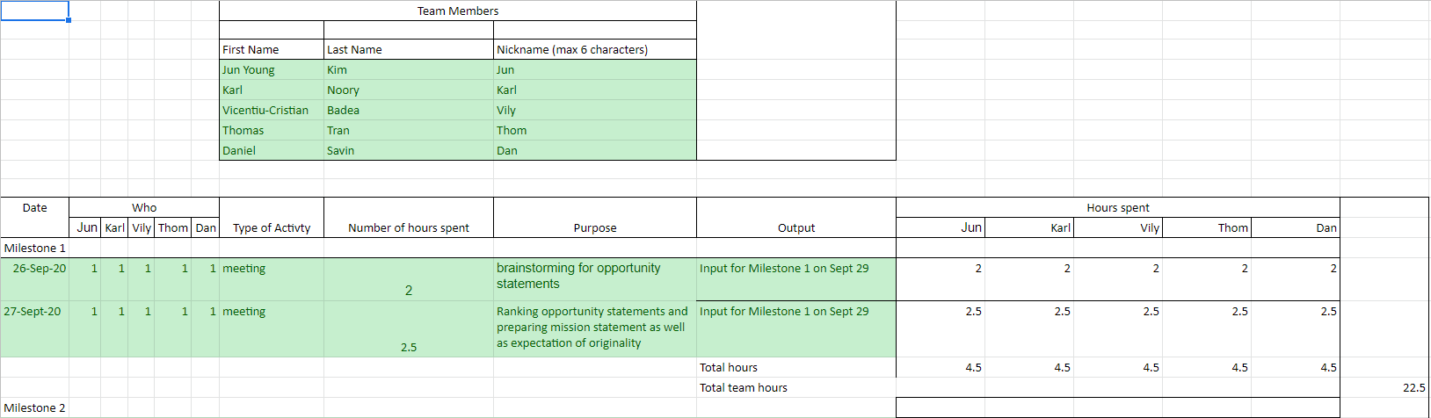

# Expectation of Originality

**Faculty of Engineering and Computer Science**

**Expectations of Originality**

This form sets out the requirements for originality for work submitted by students in the Faculty of Engineering and Computer Science. Submissions such as assignments, lab reports, project reports, computer programs and take -home exams must conform to the requirements stated on this form and to the Academic Code of Conduct. The course outline may stipulate additional requirements for the course.

1. Your submissions must be your own original work. Group submissions must be the original work of the students in the group.

2. Direct quotations must not exceed 5% of the content of a report, must be enclosed in quotation marks, and must be attributed to the source by a numerical reference citation. Note that engineering reports rarely contain direct quotations.

3. Material paraphrased or taken from a source must be attributed to the source by a numerical reference citation.

4. Text that is inserted from a web site must be enclosed in quotation marks and attributed to the web site by numerical reference citation.

5. Drawings, diagrams, photos, maps or other visual material taken from a source must be attributed to that source by a numerical reference citation.

6. No part of any assignment, lab report or project report submitted for this course can be submitted for any other course.

7. In preparing your submissions, the work of other past or present students cannot be consulted, used, copied, paraphrased or relied upon in any manner whatsoever.

8. Your submissions must consist entirely of your own or your group’s ideas, observations, calculations, information and conclusions, except for statements attributed to sources by numerical citation.

9. Your submissions cannot be edited or revised by any other student.

10. For lab reports, the data must be obtained from your own or your lab group’s experimental work.

11. For software, the code must be composed by you or by the group submitting the work, except for code that is attributed to its sources by numerical reference.

**“We certify that this submission is the original work of members of the group and meets** **the Faculty's Expectations of Originality”.**

We certify that we have read the requirements set out on this form, and that we are aware of these requirements. We certify that all the work we will submit for this course will comply with these requirements and with additional requirements stated in the course outline.

Course number: ELEC/COEN 390

Instructor: Dr. Wahab Hamou-Lhadj

Date: 29 September 2020

Daniel Savin - 40010051



Jun Young Kim - 40063176



Karl Noory - 40059592



Thomas Tran - 40095654



Vicentiu-Cristian Badea - 40027683

